T distribution

Def

PDF

$$f\left(t\right)$$

= $$\frac{Gamma\left(\frac{v+1}{2}\right)}{{\left(v⋅pi\left(\right)\right)}^{\frac{1}{2}}⋅Gamma\left(\frac{v}{2}\right)}{\left(1+\frac{t^{2}}{v}\right)}^{−\frac{\left(v+1\right)}{2}}$$

= $$\frac{1}{v^{\frac{1}{2}}⋅B\left(\frac{1}{2},\frac{v}{2}\right)}{\left(1+\frac{t^{2}}{v}\right)}^{−\frac{\left(v+1\right)}{2}}$$

where B is a beta function.

CDF

$$F\left(t\right)$$

= $$integral\left(f\left(x\right)dx,x=−inf,x=\inf{}\right)$$

= $$integral\left(f\left(x\right)dx,x=−inf,x=t\right)$$

(since it always is 0 from t to inf)

Special Case:

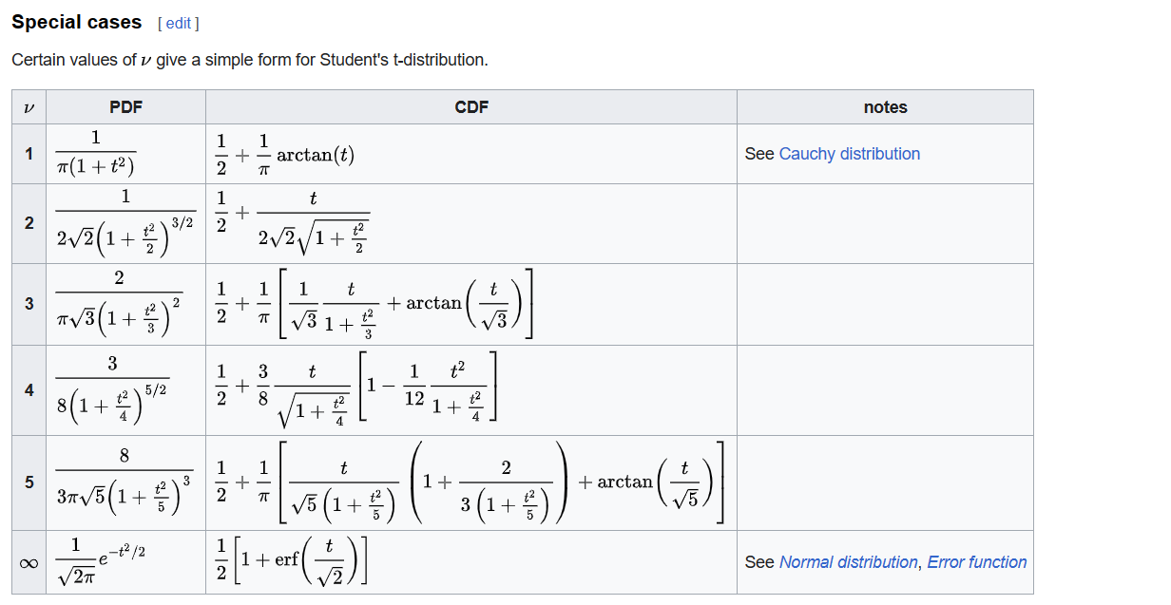

Expected Value

$$E\left[X\right]=0$$

Really? $$E\left[X\right]=0$$? Yes. That’s prove it.

Proof:

$$E\left[X\right]$$

$$integral\left(xf\left(x\right)dx,x=−inf,x=\inf{}\right)$$

$$integral\left(xf\left(x\right)dx,x=−inf,x=0\right)$$

$$integral\left(xf\left(x\right)dx,x=0,x=\inf{}\right)$$

Variance

Moments

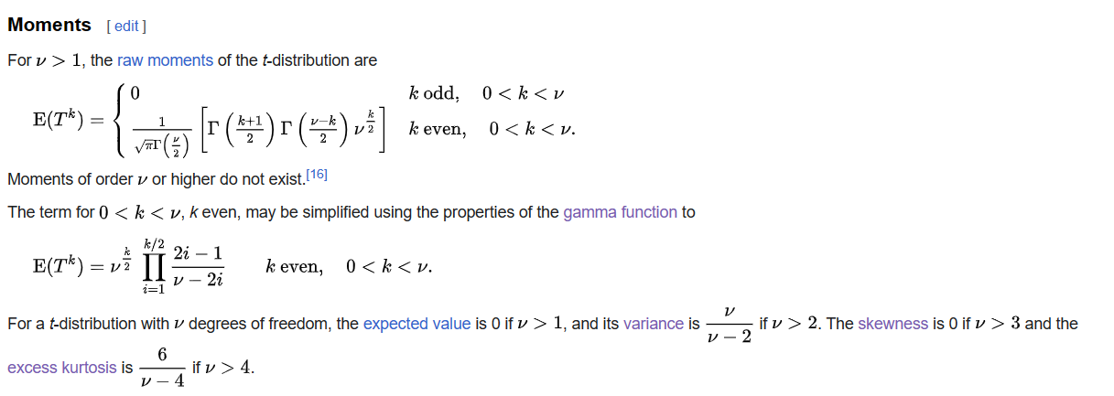

Ref

For more detailed description about t distribution, see Wiki:

[Student's t-distribution - Wikipedia](https://en.wikipedia.org/wiki/Student%27s_t-distribution)

For proof of mean and variance of t distribution, see statlect:

[Student's t distribution | Properties, proofs, exercises (statlect.com)](https://www.statlect.com/probability-distributions/student-t-distribution)